Assignment 2

Due date : 4/8/2022

1. (Slightly modified version of Ex 3-32 on page 113) An appliance dealer sells three different models of upright freezers having 13.2, 15.9, and 19.1 cubic feet of storage space, respectively. Let X = the amount of storage space purchased by the next customer to buy a freezer. Suppose that X has pmf.

|  |  |
| --- | --- |
| x | 13.2 15.9 19.1 |
| p(x) | 0.3 0.45 0.25 |

Compute E(X), E(X2), and V(X).

E(X) = 13.2*0.3+ 15.9*0.45 + 19.1*0.25 = 15.89

E(X^2) = (13.2^2)*0.3+ (15.9^2)*0.45 + (19.1^2)*0.25

V(X) = E(X^2)-E(X)^2 = 4.7469

If the price of a freezer having capacity X cubic feet is 25X - 8.5, what is the expected price paid by the next customer to buy a freezer?

E(25X-8.5) = 25*E(X)-8.5 = 25*15.89-8.5 = 388.75

What is the variance of the price 25X - 8.5 paid by the next customer?

V(25X-8.5) = 25^2*V(X) = 160774.375

Suppose that although the rated capacity of a freezer is X, the actual capacity is

h(X) = X – 0.01 X2. What is the expected actual capacity of the freezer purchased by the next customer?

|  |  |  |  |
| --- | --- | --- | --- |
| X | 13.2 | 15.9 | 19.1 |
| X(1-0.01X) | 11.4576 | 13.3719 | 15.4519 |
| p | 0.3 | 0.45 | 0.25 |
| X(1-0.01X)*P | 3.43728 | 6.017355 | 3.862975 |
|  |  |  |  |
| E(X(1-0.01X)) | 13.31761 |  |  |

2. (Slightly modified version of Ex 2-66 on page 122) An airport limousine can accommodate up to four passengers on any one trip. The company will accept a maximum of six reservations for a trip, and a passenger must have a reservation. From previous records, 25% of all those making reservations do not appear for the trip. Answer the following questions, assuming independence wherever appropriate.

a. If six reservations are made, what is the probability that at least one individual with a reservation cannot be accommodated on the trip?

1-6C6*(0.75)^6*(0.25)^0 = 0.822021484

b. If six reservations are made, what is the expected number of available places when the limousine departs?

6*0.822021484 = 4.93212891

c. Suppose the probability distribution of the number of reservations made is given in the accompanying table.

|  |  |
| --- | --- |
| Number of observations | 3 4 5 6 |
| Probability | 0.1 0.2 0.3 0.4 |

Let X denote the number of passengers on a randomly selected trip. Obtain the probability that X=4 (P(X=4).

|  |  |  |
| --- | --- | --- |
|  | appear | disapear |
| 1 person | 0.75 | 0.25 |
|  |  |  |
| avg observation | 5 |  |
| 4 people 5 observation | 0.003171212 |  |

= (0.75^4)^5

3. (Slightly modified version of Ex 3-84 on page 132) Suppose that only 0.10% of all computers of a certain type experience CPU failure during the warranty period. Consider a sample of 10,000 computers.

What are the expected value and standard deviation of the number of computers in the sample that have the defect?

expected value = 0.001 * 10000 = 10

standard deviation = (0.001 * 10000 * 0.999)^(1/2) = 3.160696

What is the (approximate) probability that more than 10 sampled computers have the defect?

X = number of failure

P(X>10) = 1- P(X<=10)= 1- 0.5829946 = 0.4170054

*R codes for answer

a0 = (10000,0) * (0.999)^(10000-0) * (0.001)^0

a1 = choose(10000,1) * (0.999)^(10000-1) * (0.001)^1

a2 = choose(10000,2) * (0.999)^(10000-2) * (0.001)^2

a3 = choose(10000,3) * (0.999)^(10000-3) * (0.001)^3

a4 = choose(10000,4) * (0.999)^(10000-4) * (0.001)^4

a5 = choose(10000,5) * (0.999)^(10000-5) * (0.001)^5

a6 = choose(10000,6) * (0.999)^(10000-6) * (0.001)^6

a7 = choose(10000,7) * (0.999)^(10000-7) * (0.001)^7

a8 = choose(10000,8) * (0.999)^(10000-8) * (0.001)^8

a9 = choose(10000,9) * (0.999)^(10000-9) * (0.001)^9

a10 = choose(10000,10) * (0.999)^(10000-10) * (0.001)^10

a = a1+a2+a3+a4+a5+a6+a7+a8+a9+a10

print(1-a)

What is the (approximate) probability that no sampled computers have the defect?

0.999^10000 = 0.00452%

4. (Slightly modified version of Ex 3-93 on page 133) Suppose small aircraft arrive at a certain airport according to a Poisson process with rate $λ=7$ per hour, so that the number of arrivals during a time period of t hours is a Poisson rv with parameter $λ=7t$.

a. What is the probability that exactly 6 small aircraft arrive during a 1-hour period? At least 6? At least 10?

dpois(x = 6, lambda = 7) = 0.1490028

1 - ppois(q = 5, lambda = 7, lower.tail = TRUE) = 0.6992917

1 - ppois(q = 9, lambda = 7, lower.tail = TRUE) = 0.1695041

b. What are the expected value and standard deviation of the number of small aircraft that arrive during a 90-min period?

$$λ=7t=7*1.5=10.5$$

Expected value = $λ=10.5$

Standard deviation = $\sqrt{λ}= 3.24037$

c. What is the probability that at least 20 small aircraft arrive during a 2.5-hour period? That at most 10 arrive during this period?

$$λ=7t=7*2.5=17.5$$

1-sum(dpois(x=c(0:20), lambda = 17.5)) = 0.2305656

sum(dpois(x=c(0:10),lambda = 17.5)) = 0.03874505

5. (Slightly modified version of Ex 4-22 on page 151) The weekly demand for propane gas (in 1000s of gallons) from a particular facility is an rv X with pdf

$f\left(x\right)=\left\{\begin{matrix}2\left(1-\frac{1}{x^{2}}\right) & 1≤x≤2 \\ 0 & otherwise\end{matrix}\right.$

Calculate $P\left(X≤1.5\right)$

F(1.5)-F(1) = 0.333333

Calculate $P\left(1.5≤X≤1.8\right)$

F(1.8)-F(1.5) = 0.377778

Obtain the cumulative distribution function.

F(x) =

0 (x<1)

2x+2x^(-1)-4 (1=<x<=2)

1(x>2)

Calculate the median of X.

median -> 50% percentile

about 1.640672

Calculate the $E\left(X\right)$

$$\int{xf(x)}dx$$

3-2ln2

Calculate the $E\left(X^{2}\right)$

$$\int{x^{2}f(x)dx}$$

about 2.666667 = 8/3

Calculate $V\left(X\right)$

$$\int{x^{2}f(x)dx}-{(\int{xf(x)}dx)}^{2}$$

about 0.0626208

If 1.5 thousand gallons are in stock at the beginning of the week and no new supply is due in during the week, how much of the 1.5 thousand gallons is expected to be left at the end of the week? [Hint: Let h(x) = amount left when demand = x.]

h(x) = 1.5 – f(x)

= 3(1-x^(-2)) (1<=x<=2)

= 0 (otherwise)

expected left gas = = 1.5

6. (Slightly modified version of Ex 4-27 on page 152) Example 4.5 introduced the concept of time headway in traffic flow and proposed a particular distribution for X = the headway between two randomly selected consecutive cars (sec). Suppose that in a different traffic environment, the distribution of time headway has the form

$f\left(x\right)=\left\{\begin{matrix}\frac{k}{x^{4}} & x>1 \\ 0 & x≤1\end{matrix}\right.$

Determine the value of k for which f(x) is a legitimate pdf.

$$\int{f(x)}dx=1$$

k/3= 1, k=1

Obtain the cumulative distribution function.

F(x) = -x^(-3)+1 (x>1) or 0 (x<=1)

Use the cdf from (b) to determine the probability that headway exceeds 2 sec and also the probability that headway is between 2 and 3 sec.

1- F(2) = 0.125

F(3)-F(2) = 0.087963

Obtain the mean value of headway and the standard deviation of headway.

$\int{xf(x)}dx$ = 1.5

$\int{x^{2}f(x)dx}-{\left(\int{xf\left(x\right)}dx\right)}^{2}=3-{1.5}^{2}=0.75$ = V(x)

$\sqrt{0.75}=standard deviation=$ 0.8660254

What is the probability that headway is within 1 standard deviation of the mean value?

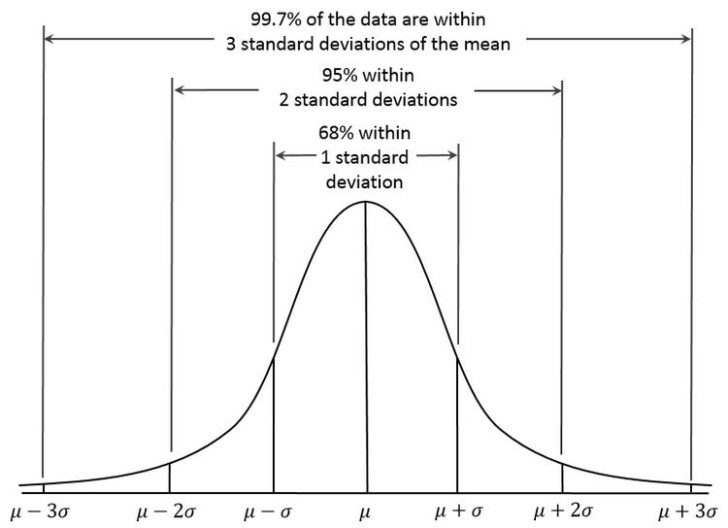

around 68%